**Clinic Management system**

**BY**

**KIRAN KHATIWADA**

**T.U. Registration Number: 7-2-450-14-2018**

**T.U. Exam Roll Number: 9074/18**

*A Summer Project Report Submitted to*

**Faculty of Management, Tribhuvan University**

in partial fulfillment of the requirements for the degree of

**Bachelor of Information Management**

At the

**Thames International College**

Old Baneshwor, Kathmandu

August 27, 2022

**STUDENT DECLARATION**

This is to certify that I have completed the Summer Project entitled “**Clinic Management System**” under the guidance of **Mr. Nischeet Ratna Tuladhar** in partial fulfillment of the requirements for the degree of **Bachelor of Information Management** at Faculty of Management, Tribhuvan University. This is my original work and I have not submitted it earlier elsewhere.

Date: August 27, 2022

Signature:

Name: Suraj Karki

iii

**CERTIFICATE FROM THE SUPERVISOR**

This is to certify that the summer project entitled “**Clinic Management System**” is an academic work done by **Suraj Karki** submitted in the partial fulfillment of the requirements for the degree of **Bachelor of Information Management** at Faculty of Management, Tribhuvan University under my guidance and supervision. To the best of my knowledge, the information presented by him in the summer project report has not been submitted earlier.

…………………………...

Signature of the Supervisor

Name: Mr. Nischeet Ratna Tuladhar

Designation: Project Supervisor

Date: August 27, 2022

iv

**ACKNOWLEGEMENTS**

The completion of this project report would not have been possible without the continuous support and guidance of my friends and faculty members of Thames International College. Without their help and co-operation, this report would not have been completed at proper manner. I would like to extend my sincere gratitude to everyone who has helped me in the completion of this project and preparation of this report specially one of my close friends Mr. Sishir Wagle who helped me in each and every step of my project journey. Foremost, I would like to thank Tribhuvan University for giving us this opportunity which allows and helps every BIM student to acquire, understand as well as enhance knowledge on IT platform.

I would like to express my sincere gratitude to our course facilitator Mr**. Nischeet Ratna Tuladhar** for his continuous guidance, suggestions, encouragement and comments for preparation and completion of this project from the very beginning. At last, but not the least, I am thankful to all my teachers and friends who have been always helping and encouraging me throughout this project.

v

**EXECUTIVE SUMMARY**

Samaj Sewa Poly Clinic is a clinic which is located at my home town Baniyatar Tokha-08. It was established in 2071 BS and till now it is providing the general treatment and service to the local people.

In some case it also provides service of surgery and other important treatment. Now it has enhanced its service to the next level by providing very minor treatment like dressing the wound to the greater service of X-RAY, ECG, physiotherapy, general physician, child disease specialist , orthopedic and neuron specialist , skin and woman disease treatment , and it also provides the service of ophthalmology using special advance machine which is a treatment for an eye and also a dental service. Other treatment and service includes pathology service, USG, injection and others.

Although it is providing all these treatment and services they are doing it manually which has made their service quite slow and unmanaged. Other two new clinics have been opened here and they are facing huge problem of competition and also these two new clinics are using new advanced system to run the clinic. And this samaj clinic is one of my close friend’s clinic and he also suggested me to build a website for this. So the main goal of the project is to develop a clinic management system for this clinic so that it helps to interact with patient and doctor and to get medicine and appointment and to view the availability of doctor. XP Agile Methodology of Software Engineering is used to develop the project. The core language used in completion of the project is PHP. The database used is MYSQL. The front end uses HTML, CSS, JavaScript, Bootstrap and JQuery. The project is developed using OOD concepts.

The main benefit that the user of this system is the growth of their clinic business and the important thing is patient would not have to queue in line to get counseling with doctor and to get better treatment service. The website will deliver everything regarding the clinic management so that neither patient nor doctor have to face difficulty. This project will also be purely focused on the end user experiences including Patient and doctor login plus viewing appointment and doctor and adding patient and also a doctor. Altogether, this project will help in achieving the clinic operations in smooth and efficient way.

vi

**TABLE OF CONTENTS**

*Cover Page i*

*Approval Letter ii*

*Student Declaration iii*

*Certificate from the Supervisor iv*

*Acknowledgments v*

*Executive Summary vi*

*Table of Contents vii*

*List of Figures and Table viii*

*Abbreviations*  *ix*

**Chapter I Introduction**

1.1 Background Introduction of the Organization 1

1.2 Current Situation of the Organization 1

1.3 Problem of the report 1

1.4 Objective of the report 1

1.5 Methodology/Procedure adopted for writing the report 2

**Chapter II Tasks and Activities Performed**

2.1 Requirement Analysis 3

2.1.1 Data collection 3

2.1.2 Requirement Specification 3

2.1.2.1 Functional requirements 3

2.1.2.2 Non-functional Requirements 4

2.1.3 Feasibility study 5

2.2 Planning 6

2.2.1 Resource Requirements 6

2.2.1.1 Minimum Hardware Requirements 6

2.2.1.2 System Requirement 6

2.2.2 Time Scheduling 7

2.3 System Design 8

2.3.1 System Architecture 9

2.3.2 Data flow Diagram 10

2.4 Implementation and Testing 11

2.4.1 Coding Tools 11

2.4.2 Testing 12

**Chapter III Discussion and Conclusion**

3.1 Discussions 13

3.2 Conclusion 13

**References 14**

**Appendices 15-20**

vii

**LIST OF FIGURES AND TABLES**

**Page**

Figure 1.1 XP Agile Methodology 2

Table 2.1 Gantt chart of Project Overview 7

Figure 2.2 Use Case diagram 8

Figure 2.3 ER diagram of the system 8

Figure 2.4 Activity Diagram 8

Figure 2.5 System Architecture 9

Figure 2.6 Context Diagram 10

Figure 2.7 Data Flow Diagram at Level One 10

Table 2.8 Test Case 12

viii

**ABBREVIATIONS**

HTML : Hyper Text Markup Language

CSS : Cascading Style Sheet

JS : JavaScript

OOP : Object Oriented Programming

HTTP : Hypertext Transfer Protocol

SDLC : Software Development Lifecycle

IT : Information Technology

CRUD : Create, Read Update and Delete

MVC : Model View Controller

API : Application Programming Interface

SQL : Structure Query Language

DBMS : Database Management System

Admin : Administrator

XAMPP : Cross-platform(X), Apache(A), Maria DB(A), PHP(P), AND Perl(P)

ASP : Active Server Pages

I/O : Input/output

CPU : Central Processing Unit

GB : Gigabyte

RAM : Random Access Memory

OS : Operating System

UI : User Interface

TDD : Test Driven Development

XP : Extreme Programming

ix

**CHAPTER 1**

**INTRODUCTION**

* 1. **Background**

Samaj Sewa Poly Clinic is a clinic which is located at my home town Baniyatar. It was established in 2071 BS and till now it is providing the general treatment and service to the local people. In some case it also provides service of surgery and other important treatment. Now it has enhanced its service to the next level by providing very minor treatment like dressing the wound to the greater service of X-RAY, ECG, physiotherapy, general physician, child disease specialist, orthopedic and neuron specialist, skin and woman disease treatment, and it also provides the service of ophthalmology using special advance machine which is a treatment for an eye and also a dental service.

**1.2 Current Situation of the Organization**

The clinic is currently only able to operate its operations manually even the registration and entry of the new patient. The patients are taking the appointment of the doctor as per the doctor hours of visit. The available medicines are distributed quite not properly due to correct system for it. So clinic is approaching to have a better website that helps to manage the current problem.

**1.3 Problem of the Report**

The clinic main issue is not being effectively able to provide clinic service to the patient and those who are acquiring clinic service. There is no any service which has been done by using certain system. The main issue is patient does not get information about availability of doctor. They anyhow must visit to the clinic to check whether doctor has arrives or not. Similar case for appointment, patient and facing scheduling of appointment and doctor visiting hour is not properly managed. Also there is problem in case of department of doctor.

**1.4 Objective of the Report**

The project aims to create a fully functional and dynamic website regarding clinic management for samaj sewa poly clinic to manage the patient appointment, doctor visiting hours, availability of the doctor as per the need of patient. Likewise, to know which department the doctor is of. The project is intended to be a smaller solution to the clinic’s current problems and help to enhance the service of clinic in a better and efficient way.

Now the main objectives of the project are as follows:

* To develop a well-integrated and user friendly online clinic management system for the clinic.
* To develop a user friendly system where user can sign up themselves and view doctor, department of doctor active and inactive status of doctor.
* Admin can control the system by getting the access to view new patient and new doctor and also delete and approved them.
* Similarly all three end users can view availability of medicine.

1

**1.5 Methodology/Procedure adopted for writing the report**

The project report is created using Microsoft Word 2013 by complying with the TU Report Writing Guidelines. The References is done in APA Style of Referencing.

Finally for the completion this project, XP agile methodology was implemented which ensured smooth and effective functionality and providing the benefit of flexibility. The Agile software development methodology is one of the simplest and effective processes to turn a vision for a business need into software solutions. Also, I decided to go with this methodology because of the following reasons.

* This method proposes incremental and iterative approach to software design. Also, the development process is iterative, and the project is executed in short (2-4) weeks iterations.
* Maintaining simplicity through constant refactoring of code.
* In XP, a customer or user is part of the XP team and is responsible for making decisions on requirements.
* It proposes constant code improvement (refactoring) to make changes easier when they have to be implemented.
* It follows Test-First and TDD to check the software codes are executed without any errors. Also, regular and rigorous testing is implemented in this method.
* Errors can be fixed in the middle of the project.

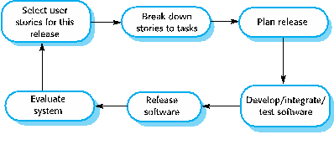

Fig 1.1 XP Agile Methodology

2

**CHAPTER II**

**TASKS AND ACTIVITIES PERFORMED**

**2.1 Requirement Analysis of the project**

The main objective of the project is to provide good and interactive user interface. Extensive analysis and research have been performed to identify the needs and behaviors of the various users.

* To provide better interaction and user-friendly website, a navigation bar should be made so that the users can easily navigate their way through the website.
* Also, to enhance the ease of user, users should be able to view the doctor in or out status.
* To increase user interaction the user should be able to view the availability of medicine and also to add new medicine.
* The users should be able to view the department of the doctor and along with the type of treatment they needed.
* The user should able to approve the entry of new patient and new doctor.
* The admins should only be granted the permission to the admin control page where they are able to 0performs certain operations like approve, edit, delete, and also to add new medicine and department type.
* The admins should only be granted the permission to the admin control page where they are able to 0performs certain operations like approve, edit, delete, and also to add new medicine and department type.

**2.1.1 Data Collection**

The data were collected mostly from the clinic owner and also the data were collected from the regular patient those who go there for treatment. Along with patient the data were collected from the doctors who come here to check and follow the patient.

**2.1.2 Requirement Specification**

The software is for the automation of clinic management system. It maintains two level of users one is admin level where clinic head can handle the system and another is user level where doctor and patient can use the respective system of their own.

**2.1.2.1 Functional Requirements**

Functional Requirements describes functionality or system services in detail. This includes different functional or operational features that need to be included in the system according to the requirement. The projects functional requirements are as follows:

* **Email and password must match to login:**

The email and password entered during registration must match during the login process in order for a user to be logged-in to the system.

* **Passwords must be six characters long:**

The passwords entered by the users must not be less than six characters.

3

* **All fields are required in form:**

The admin username and password set by the super-admin must match during the admin login process for an admin to be logged in successfully to the system.

* **Admin username and password must match to login:**

The admin username and password set by the super-admin must match during the admin login process for an admin to be logged in successfully to the system.

* **Admin Control Panel:**

A control panel is the administration portion of a web account. Control panels are a way for admins to edit and manage content on their websites, e-mail accounts, page templates, databases, website statistics etc.

Thus, the system must include the common features of administrative control panels like adding doctor and patient approving and deletion and to view type of treatment and medicine. The admin control page must only be made available if the user logged in is an admin otherwise the page must not be displayed to the users.

* **Once user is logged in, login page should not be displayed:**

Once the user is logged in to the system, the login in page must not be made displayed again in the system until the user is logged out or the session expires.

* **User-Friendly Website:**

The increasing usage of mobile phone has had a massive impact on the growth this system as it makes people conscious about their health. So a highly optimized website using responsive design especially for mobile phones is recommended.

* **Search Box:**

Locating the content easily for the user is an important role of UX which is where the search box is introduced. No matter where each user enters the website, a search bar must be displayed so that the option to find particular products is fast. Thus, the system must include this feature where users must be able to locate their search query by simply searching for specific words and phrases effortlessly.

* **Navigation Bar**

The navigation bar is an important element of a website's design since it allows users to quickly visit any section within the site. If you've ever visited a website without a navigation bar, you may have found it is difficult to locate the page you need. Thus, the navigation bar is part of the main website template. So, the system should have a side-navigation bar displayed on most, if not all, pages within the website.

3

**2.1.2.2 Non-functional Requirements**

Non-Functional Requirements are the constraints or the requirements imposed on the  
system. They specify the quality attribute of the software. Non-Functional Requirements deal  
with issues like scalability, maintainability, performance, portability, security, reliability,  
and many more.

1. **Product Requirements**

Product requirements are those requirements which specify that the delivered product must behave in a particular way.

* + - * **Availability**

The website shall be made available to the users 24/7 and the project must run on all platforms including mobile devices as well. It must be available at the time of operations.  
It must not be broke down while operating the system by the users.

* + - * **Scalability**

The project shall be made scalable so that it will be easy to scale the project to other platforms or mobile devices. The project must also implement CRUD methods in order to make it more scalable.

* + - * **Performance**

Performance defines how fast a software system or a particular piece of it responds to certain users’ actions under a certain workload. In most cases, this metric explains how long a user must wait before the target operation happens.

1. **Organizational Requirements**

Organizational requirements are those requirements which are a consequence of organizational policies and procedures.

* + - * **Authorization**

The admin login data is only made accessible to the users at admin level so any unauthorized admin access is denied so that the attacker may not have access to the admin privileges.

1. **External Requirements**

External requirements are those requirements which arise from factors which are external to the system and its development process.

* + - * **Legislative Requirements**

The system shall not disclose any personal information about the customers apart from their names and reference number to the operators of the system except the authorized admin and to any outside sources.

* + - **Security**

The project shall implement data privacy as stated by the cyber law so that the data of the users are kept confidential and data integrity is maintained.

4

**2.1.3 Feasibility Study**

1. **Economic Feasibility**

The project being a web application it will have an associated hosting cost. The system was  
developed using free open-source software like PHP and MySQL. So, the cost of building the project and maintenance will be low. Bug fixes will have an associated cost. Mainly the  
potential market will be the local patients from my locality. The project is economically feasible as the only cost involved is having a computer with the minimum system requirements. Besides the associated cost, there will be plenty of benefits like the project will help in attracting various new treatments to the patient at free of cost like making an offers. The project of going online will help in increasing the number of patients and increased the revenue establishing the project in the internet means that the clinic will have better exposure to outside also. The consulting charge of the doctors can also be implemented to help generate additional revenue.

Thus, the project is economically feasible to develop. Other costs that are relevant is the cost of the payment system, whether it is taking online payment directly from the website other alternative way.

1. **Technical Feasibility**

To develop a system or website requires a high-speed connection to the Internet, a web  
server, and software. The system uses PHP, HTML, CSS, JavaScript which is easily available  
for the developers to develop the project. Also, the system uses MySQL for database  
connection has been preferred over the other possibilities because of the following reasons:

* + 1. MySQL is license free.
    2. It can handle 10000+ records.
    3. It is an ideal database type to create a prototype of a website.
    4. The database can be easily upgraded to MS SQL at a later date.

The project is economically feasible as the only cost involved is having a computer with the minimum system requirements. As for the users, to access the website the only cost involved will be in getting access to the Internet. The minimum technical aspects required to deploy the system are as follows:

Operating Environment:

WinXP/7/8/8.1/10/MacPlatform.  
MySQLServer.  
For Users: Internet Browser with Internet Connection. Thus, by assessing the clinic’s technical capacity it is feasible to develop and deploy this system.

1. **Behavioral Feasibility**

The system requires no special technical guidance and all the views available in the website are self-explanatory. The users will be well guided with warnings and failure messages for all the action taken if there are any. Also, the admins of the organization will be given a tutorial of the admin control page, if necessary by the developers. Therefore, there is overall positive attitude and feedback shown by the end users during the trial phase. Hence, the system is ready for deployment in the real world.

5

**2.2 Planning**

The project will allow free registration for the users and they have to contact with admin to admit new patient and appoint the doctor on the website. The website should be able to deliver full details of the patient, to view the number of patients admitted, to get doctor’s appointment, to add new medicine and to view and add new treatment for the patients. For now, the online payment can be done only via digital system.

**2.2.1 Resource Requirements**

By assessing the meeting with the clinic owner the following main requirements for the project were gathered. Resource requirement is a detailed summary of all types of resources required to complete project task. Resource could be human, equipment and materials needed to complete a project.

* The organization should have an access to a computer system that is connected to the Internet.
* The organization should have a registered payment method.
* The organization should hire a technically qualified admin to handle the system.

**2.2.1.1 Minimum Hardware Requirements**

* OS: Windows XP/7/8/10 or greater or MAC OS
* RAM: 8GB
* Hard Disk space: 10 GB or more.
* Minimum database space: 10GB.

**2.2.1.2 System Requirements**

Following are the system requirements.

* OS(Window 10)
* MYSQL(for database)
* XAMPP Server(For System Deployment)
* Browser(Google Chrome)
* Online payment method

6

**2.2.2 Time Scheduling**

A Gantt chart is a bar chart that provides a visual view of tasks scheduled over time. The chart lists the task to be performed on the vertical axis and time interval on the horizontal axis. It is used for planning projects of all sizes, and it is a useful way of showing what work is scheduled to be done on a specific day. It can also help you view the start and end dates of a project in one simple chart.

|  |  |  |  |  |  |  |  |  |
| --- | --- | --- | --- | --- | --- | --- | --- | --- |
| Tasks  Performed for  Clinic  Management System | June 2022 | | | | August 2022 | | | |
| 1st week | 2nd week | 3rd week | 4th S week | 1st week | 2nd week | 3rd week | 4th week |
| Planning |  | |  |  |  |  |  |  |
| Analysis |  |  |  |  |  |  |  |  |
| Designing |  |  |  |  | | |  |  |
| Implementation and  support |  |  |  |  |  |  |  |  |
| Testing |  |  |  |  |  |  |  |  |

Table 2.1 Gantt chart of Project Overview.

7

**2.3 System Design**

System design is the process of designing the elements of a system such as the architecture, modules and components, the different interfaces of those components and the data that goes through that system. The purpose of the System Design process is to provide sufficient detailed data and information about the system and its system elements to enable the implementation consistent with architectural entities as defined in models and views of the system architecture. Time, cost, maintainability, scalability, reliability, efficiency, user experience etc. are some other factors that affect the system design for this e-clinic.

Below are the different design mechanisms of the proposed “Clinic Management System”.

* **Use Case Diagram**

A use case diagram is a graphical depiction of a user's possible interactions with a system. It can summarize the details of your system's users (also known as actors) and their interactions with the system. These diagrams are used to gather the requirements of a system including internal and external influences.

Following use case diagram represents the working of the Clinic Management System:

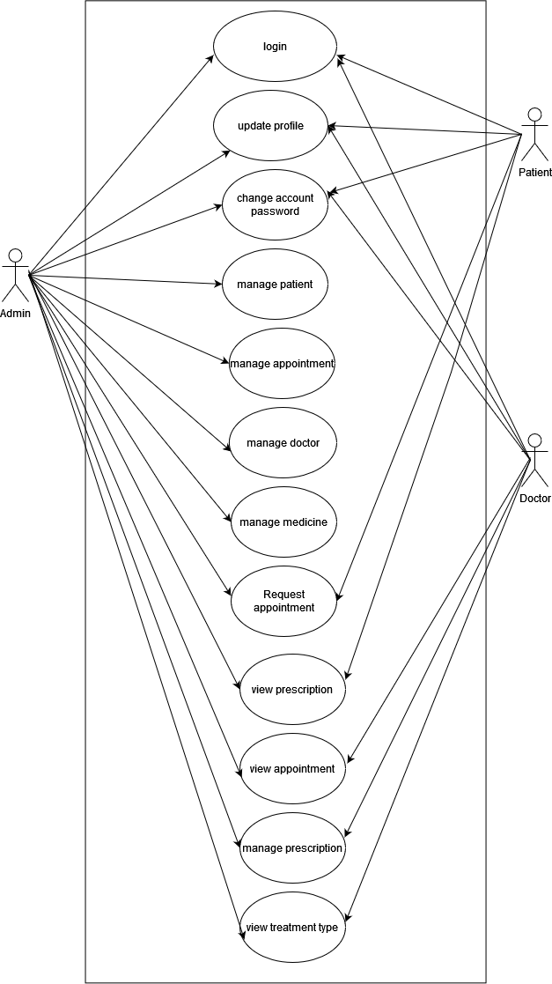

Fig 2.2 Use Case Diagram

8

* **ER Diagram**

This is the ER diagram to visualize how entities are connected in a general way. Here, admin/user, patient, doctor are the entities. The diagram shows the relation between these entities.

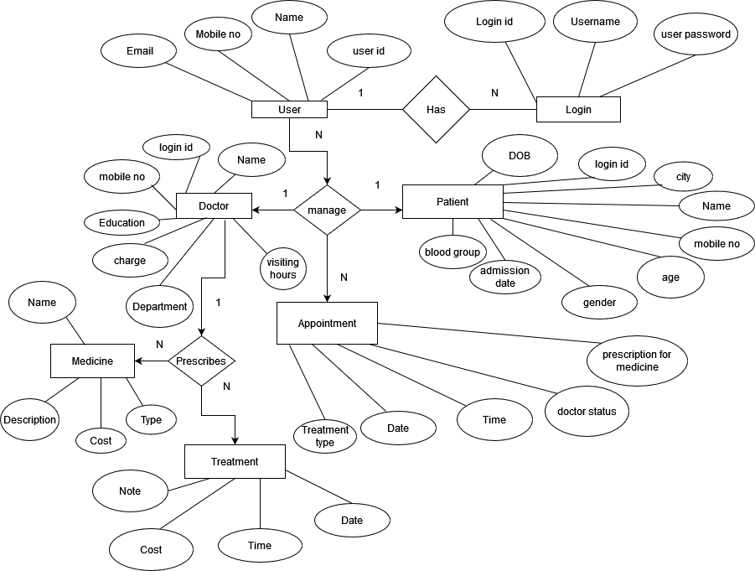

Fig 2.3 ER diagram of the system

8

* **Activity Diagram**

Activity diagram is another important behavioral diagram in UML diagram to describe dynamic aspects of the system. Activity diagram is essentially an advanced version of flow chart that modeling the flow from one activity to another activity. Activity Diagrams describe how activities are coordinated to provide a service which can be at different levels of abstraction. The activity diagram for the clinic management system is given below.

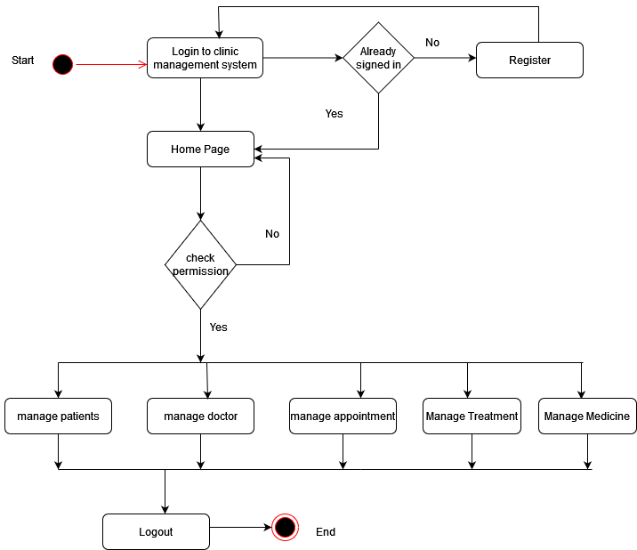

Fig 2.4 Activity Diagram

8

**2.3.1 System Architecture**

System architecture is the conceptual model that defines the structure, behavior, and more  
views of a system. An architecture description is a formal description and representation of  
a system, organized in a way that supports reasoning about the structures and behaviors of  
the system. The following diagram represents the architecture of the system. It describes the systems’ major components, their relationships (structures), and how they interact with each other.

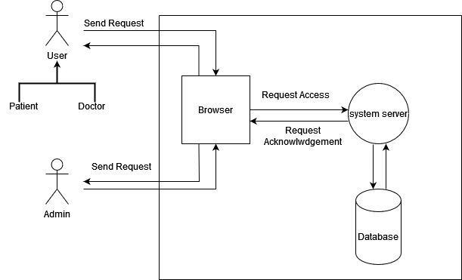

Fig 2.5 System Architecture

9

**2.3.2 Data Flow Diagram**

A data flow diagram (DFD) maps out the flow of information for any process or system. It uses  
defined symbols like rectangles, circles and arrows, plus short text labels, to show data inputs,  
outputs, storage points and the routes between each destination. They can be used to analyze an  
existing system or model a new one. Like all the best diagrams and charts, a DFD can often visually “say” things that would be hard to explain in words. A data flow diagram can dive into progressively more detail by using levels and layers, zeroing in on a particular piece. DFD levels are numbered 0, 1. The DFD diagram for clinic management system is given below:

* **Level-0 DFD:**

DFD Level 0 is also called a Context Diagram. It’s a basic overview of the whole system or process being analyzed or modeled. It’s designed to be an at-a-glance view, showing the system as a single high-level process, with its relationship to external entities.

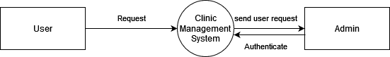

Fig 2.6 Context Diagram

* **Level-1 DFD**

DFD Level 1 provides a more detailed breakout of pieces of the Context Level Diagram. You will  
highlight the main functions carried out by the system, as you break down the high-level process of the Context Diagram into its sub-processes.

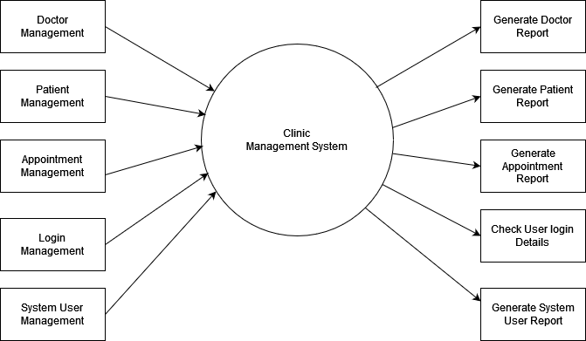

Fig 2.7 Data Flow Diagram at Level One

10

## **2.4 Implementation and Testing**

A website must be implemented for it use. Most of the design decisions are made in the implementation phase. Issues like use of images, design and functionality of the pages are design choices during implementation. It is the test program that exercises the complete system in its actual environment to determine its capabilities and limitations which also demonstrates that the system is financially operative and is compatible with the other subsystems and supporting elements required for its operational deployment.

**2.4.1 Coding Tools**

The project was built using the following tools and technologies.

1. **Front End Development**

**•HTML CSS, and JS**

HTML is used in the project to create basic page layout. The webpages are styled using CSS and the responsive features are added using JavaScript. The front-end of the project is developed using these three core technologies.

**• Bootstrap**

Bootstrap is used for designing websites and web applications. It is a free front-end framework for faster and easier web development. Bootstrap is used in this project to design some custom components like buttons, tables, forms and other components.

1. **Back End Development**

* **PHP**

PHP is a powerful tool for making dynamic and interactive Web pages. It is a server-side scripting language that is embedded in HTML.PHP itself is an OOP. It is integrated with a number of popular databases like MySQL, Oracle etc. PHP is used in this project as a core programming language to manage dynamic content, databases and session tracking.

1. **Database**

**• MySQL**

MySQL is an open-source relational database management system based on SQL. The application is used for a wide range of purposes such as data warehousing, e-commerce, and logging applications. There are 5 tables all together in the database for the project.

1. **Server**

**• XAMPP**

XAMPP is a free and open-source cross-platform web server solution stack package developed by Apache Friends consisting mainly of the Apache HTTP Server, Maria DB database, and interpreters for scripts written in the PHP and Perl programming languages. Apache server is used in the Project for the local deployment of the project.

11

1. **Web development tool**

**• Visual Studio Code**

Visual Studio Code is a source-code editor made by Microsoft for Windows, Linux and macOS. It is a streamlined code editor with support for development operations like debugging, task running, and version control. Visual Studio Code was used during the development of the project.

.

11

**2.4.2 Testing**

Testing is the process of discovering the errors. Testing is intended to show that a program does what is intended to do and to discover program defects. Testing can only show the presence of errors in a program. The testing of the system is to establish the confidence that the software system must be good enough for its intended use. During testing phase different defect are discovered before it is put into the use.

|  |  |  |  |
| --- | --- | --- | --- |
| S.N. | Case | Test | |
| Yes | No |
| 1. | User can login with valid password. |  |  |
| 2. | User can login without register. |  |  |
| 3. | Admin is able to modify and view the user details and their activity details. |  |  |
| 4. | All users including admin are able to logout successfully. |  |  |
| 5. | Only admin can control the admin panel. |  |  |
| 6. | Clinic Management system has an option to add new patient and doctor. |  |  |
| 7. | Authorized users can see the doctor details in the system like the doctors’ timings and fees. |  |  |
| 8. | Admin can delete patient and doctor information. |  |  |
| 9. | Admin can add the type of treatment patient want. |  |  |
| 10 | Admin can add the medicine required |  |  |
| 11. | Patient can view prescription. |  |  |
| 12. | Patient can control doctor portol |  |  |
| 13. | Patient can view treatment record |  |  |
| 14. | Doctor can fix and view the visiting hours |  |  |

Table: 2.8 Test Cases

12

**CHAPTER III**

**DISCUSSION AND CONCLUSION**

**3.1 Discussion**

The making of this project was very challenging, exciting and enlightening at the same time. I faced many problems, errors and challenges during the course of this project. Moreover, I learned that problems are meant to be solved and the solution of the problem does not arise in front of you until you try to solve it until you put your effort into solving it. Based on the analysis and interpretation of data, the web application titled “**Clinic Management System**” is  
able to integrate following functionalities.

* The system has role-based login (admin, patient and doctor).
* The system helps to manage patients and doctors activity.
* The system helps to create the new appointment for the patient.
* The system helps to view the appointment history to the doctor.
* The system helps to set the visiting hours of doctors for treatment.
* The system has function to view the treatment record of the patient by doctor.
* In this system doctors can view patient records.
* The system helps to add new treatment and medicine type from admin panel as per the prescription of the doctors to the patient.
* The system also helps to know which department the doctor belongs.

**3.2 Conclusion**

To conclude the description of the project, the project is developed using PHP, HTML, CSS and  
JavaScript which is based on the requirement specification of the client and the analysis of the  
existing system with flexibility for future enhancement. By analyzing and identifying the problem of the clinic this system is being developed to overcome those problems. This project is also  
concern with providing modern feature rich system to the user. In short concluding the features of  
the system, the system have provision of high security with login system through the authorized id  
and password. It has Admin login, patient login and also doctor login system individually where admin can manages all the users credentials in the clinic. Whereas, Users can login to the system and create the appointment, add treatment type add medicine type, doctor can set the visiting hours for giving treatment. Patient and doctor can view the treatment records.

Moreover, The Project entitled “**Clinic Management System**” has been successfully completed by fulfilling with all the requirements and testing scenarios. The project is able to provide all its functionalities to the concerned party i.e. **Samaj Sewa poly clinic.** I would also like to thank the clinic for giving me the opportunity to work on the project which has helped me to enhance my skills to generate creative ideas, face new challenges and tackle them in the real-time. Throughout the development process of the project, I was able to learn a lot of new things and was able to implement my learning’s from classes and individual researches too.

As the project leader, I conclude that the project shall able to help the clinic to properly manage its activities through the web application and I hope that the project has succeeded the store’s goal to  
digitalize their services.

13

**REFERENCES**

*Clinic Management System UML Diagram | FreeProjectz*. (n.d.). Clinic Management System UML Diagram | FreeProjectz. Retrieved September 8, 2022, from <https://www.freeprojectz.com/uml-diagram/clinic-management-system-uml-diagram>

*PHP Tutorial*. (n.d.). PHP Tutorial. Retrieved September 8, 2022, from <https://www.w3schools.com/php/>

Rana, K. (2019, December 2). *Test Cases for Hospital Management System - ArtOfTesting*. ArtOfTesting. <https://artoftesting.com/hospitalmanagement>

*PHP Tutorial*. (n.d.). PHP Tutorial. Retrieved September 10, 2022, from https://www.tutorialspoint.com/php/index.htm

14

**Appendices**



